**Brooklyn torah gazette**

**For parshas matos-masei 5781**

Volume 5, Issue 47 (Whole Number 247) 1 Menachem Av 5781/ July 10, 2021

**Printed L’illuy nishmas Nechama bas R’ Noach, a”h**

For a free subscription, please forward your request to [***keren18@juno.com***](mailto:keren18@juno.com)

**Darwin’s Greatest Fear –**

**The Human Eye**

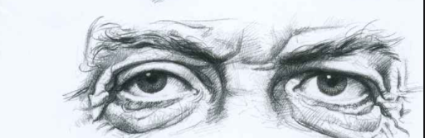

Let us imagine the following newspaper scoop:

In the world’s most sophisticated laboratory, some of the world’s leading scientists have developed what can only be described as a super camera. The newspaper article will also carry a picture of the most complicated looking camera available.

This camera works under all conditions and does not require either artificial lighting or film. Every picture is automatically relayed to a special computer, where it is processed in a fraction of a second without any developing. The super camera has the ability to capture close-up and long distance views at the same time, regardless of their size.

At the center of the camera’s lens is an automatic adjustment mechanism, which reduces aperture size when the light level is too high and allows only the necessary light to enter. When light level is low, the aperture opens automatically to allow the entry of all available light. The camera lens has an automatic zoom capability, operated by a very sophisticated electronic spring mechanism.

When light enters the camera, it triggers seven million color sensors, which automatically balance all the different colors with outstanding accuracy to create the right picture with precise color replication. When there is insufficient light to create a color picture, such as at night, when the seven million color sensors cannot work, 127 million black and white sensors come into operation. Designed and built specifically for this task, the black and white sensors successfully capture the picture.

**The Fragility of the Most Expensive**

**And Sophisticated Camera**

Given that the most expensive and sophisticated camera in the world is fragile, for the first time in photographic history, a special automatic lens cleaning system has been fitted into the camera itself. This ensures that the pictures are constantly bright and clear.

The inner surfaces of two delicate membranes are constantly being washed with a special cleaning solution as they automatically open and close over the lens surface at regular intervals. The membranes clean the lens at very high speed without reducing the quality of pictures taken by the camera. Instead of using a single membrane, covering the whole lens, the camera’s designer deliberately placed two membranes, one at the bottom and one at the top of the lens. The membranes sweep up and down respectively, meeting in the middle at the extension of their stroke. This allows them to open and close very fast, cleaning the entire lens at very high speed.

The specially designed lubrication system ensures that the lens operates with a constant supply of fluid, which also ensures that the lens can move smoothly from side to side at the same time that it is cleaned. Even the tiniest particle of dust or dirt entering the lens environment is removed immediately. The membrane and lubrication system provides the camera with the ability to work in all weathers, even during a sand storm.

**A Method of Washing Away the Dirt**

The membranes automatically close to any necessary position and can seal the lens hermetically if required. Any dirt entering the lens before it is closed is washed away from inside the seal. If large quantities of dirt enter the system, they are detected by the lubrication system sensors without any specific human intervention. They pump in more lubrication fluid, which completely washes away the dirt, leaving the lens as clean and clear as before.

One of the most impressive achievements of this super camera is its ability to take three-dimensional photographs. This advanced capability is achieved by combining two independent filming systems, each of which has all the capabilities of the system already described. The special computer used to process the pictures receives images from both lenses within a fraction of a second. Designated software processes the pictures and combines them together into a single, three-dimensional picture within milliseconds.

It is important to realize that this super camera is no more than two and a half centimeters in diameter and both lenses are permanently located in the most sophisticated creation on earth and they are called – the eyes.

Is it any wonder that even before the discovery of the amazing facts supplied above, Charles Darwin, the father of evolutionary theory, wrote that in view of the amazing perfection in the design of the eye and the visual mechanisms, he suspected that the day would come when evolutionary theory would be debunked based on knowledge of the eyes’ construction.  As Darwin put it: “Until today, the eye always gives me a cold shiver.”

*Reprinted from the Parshas Pinchas 5781 website of Hidabroot.com*

**Thoughts that Count**

**Matot-Masei**

The word "matot," which means tribes, also means staffs. Staffs symbolize stability and permanence, like a staff which is hard and strong. Masei means "journeys," and alludes to a changing and non- permanent situation. The fact that the two Torah portions of Matot and Masei are read together teaches us that even when we are traveling on a journey, for vacation or business, we must be as vigilant and unchanging in our religious observance as when we are at home. *(The Rebbe)*

*Arm some men from among you for war.* (Num. 31:3)

G-d told Moses, "You shall avenge": that Moses himself should be the one who avenges the Jews against Midian. Why, then, did Moses send others to fight the battle? Moses had lived in the land of Midian and did not want to personally harm those who had treated him well. There is a saying, "don't throw stones into the well from which you have drunk." *(Bamidbar Rabba)*

*Reprinted from the 5756/1996 Parshat Matos-Masei edition of L’Chaim Weekly.*

**Rabbi Berel Wein on**

**Parshat Matot-Maasei**

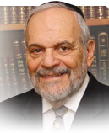

The combination of these two sections of the Torah constitutes the question, raised by all commentators over the ages, as to whether there is a connection between these two Parshiot, or is it just a matter of calendar convenience that unites them is one Torah reading on this coming Sabbath.

I have always believed that there are no random occurrences or events as they appear in the text in the Torah and in other holy writings. The Torah is not a random work, and these sections of the book are also not randomly put together. There must be a connecting bond, a common denominator that unites these two apparently disparate and different sections of the Torah.

I feel that it is in the relationship between the Jewish people and the land of Israel that is the connection that links Matot and Maasei. In this reading of Matot, we are told of the request of the tribes of Reuven and Gad to settle themselves and their families, their flocks, their wealth, and talents outside the strict borders of the land of Israel. They point out to Moshe all the advantages that they would enjoy if he allowed them to take their share in the land of Israel east of the Jordan River.

Moshe resists their plan, and sharply criticizes them for advancing it publicly. However, he  is powerless to change their minds and alter their demands. He reaches an accommodation with them, i.e.  that they will participate in the conquest of the land of Israel itself and not forsake their brothers in the struggle to obtain the land of Israel for the tribes of Israel. However, it is obvious that even this result, to settle east of the Jordan River. is a disappointment.

Advancing in history, we see that centuries later the tribes of Reuven and Gad were the earliest ones who were forced into exile, losing their land and independence.

In the second section of this week's Torah reading, we have the entire list of all the way stations that the Jewish people experienced during their sojourn in the desert of Sinai. Rashi is quick to point out that every one of these places had memories for the Jewish people, and were not just simply names of places, but, rather, descriptions of past events.

Each place was a challenge and a test.  We find in Judaism and Jewish thought that maintaining Jewish values is not always convenient. It demands sacrifice and memory of historical importance. In our time, many Jews, if not most of them, have again chosen to live outside the confines of the land of Israel. I do not mean to criticize any of them for this choice, but I merely make the observation that for almost all these Jews, it is a matter of convenience.

It is the same type of convenience that led the tribes of Reuven and Gad to prefer the pasture lands of Transjordan over the land of Israel itself. It certainly was more convenient for them to do so, but the hard truth about Judaism is that it is never convenient – it is demanding, insistent and unwavering.

Remembering fondly all the way stations that we have experienced over our long exile in this world may create within us a feeling of nostalgia, but that is only because we do not directly face the lessons of exile, and what was endured throughout the centuries. It is certainly not for me to criticize Jews who choose to live outside of the land of Israel. It is their choice, and many, if not most, have good reasons to do so. But none of this changes the historical fact that only in the land of Israel do the Jewish people have a future, and only there will they be able to truly fulfill the mission set forth for them at Mount Sinai.

*Reprinted from the current website of rabbiwein.com*

**Parshas Maasei**

**A Land that Grows Murderers**

**By Rabbi Bentzion Shafier**

**Founder of TheSmuz.com**

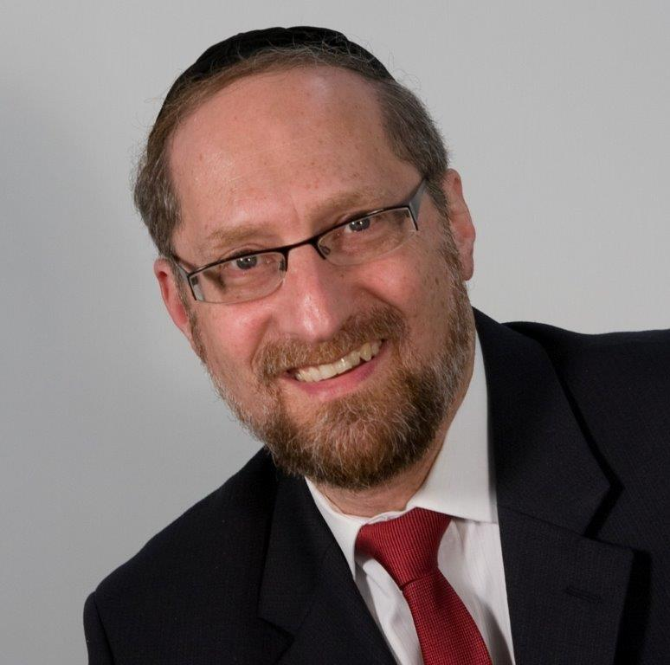

“The three cities you shall place on the other side of the Jordan, and three cities you shall place in the land of Canaan; cities of refuge they shall be.” – Bamidbar 35:14

**A Shogeg Killer**

If a man kills unintentionally, under specific conditions, he is obligated to flee to a city of refuge and remain there until the Kohain Gadol dies. While his act wasn’t premeditated and not even intentional, the Torah judges that had human life been more valuable to him, he would have been more careful, and this act would not have happened. Therefore, he is held accountable.

The Torah delineates the placement of these cities of refuge: three on the Transjordan and three in the Land of Israel. Rashi is troubled by the disparity. Only two and a half shvatim remained on the other side of the Jordan. The vast majority of the Jewish people lived inside the borders of Israel. If three cities of refuge are sufficient to service nine and a half shvatim, why should two and half shavatim need three cities? Rashi answers that according to the Gemara (Maakkos 9a), “In Gilad there are more killers.” Rashi seems to be saying that even though the area of the land and the size of the population were smaller, they would need an equal amount of cities of refuge because the cities themselves cause there to be more murders.

This Rashi seems very difficult to understand. These posukim are speaking before the Klal Yisroel entered the Land of Israel. There were no established customs or sociological factors that would affect the people living there; all of the previous occupants of the land would be removed. They were beginning with a new society. So why should one city have a higher proportion of murders than another? Does the land itself grow killers?

The answer to this question is based on understanding forces that HASHEM put into the world. This can be clarified with a moshol.

**A Modern Junk Yard**

**Electro magnetism** is a force that we are all familiar and comfortable with. And it doesn’t even surprise us that it can be used to lift thousands of pounds of metal effortlessly. But objectively, it is astounding. A force that can travel across distances, go right through objects, and cause heavy metal objects to move, and not just move, but to literally fly off the ground!

Turn the electricity on and this force can pick up full-sized vehicles. Turn it off, and they drop right back down. Yet we don’t see the force. We can’t even feel it; we could walk right through the waves and not know that they exist. This is an example of a powerful force that HASHEM created for a specific purpose.

So too, HASHEM created other forces in the world. The Gemara tells us that while certain cities grow licentiousness, other cities grow brave and wise men. HASHEM created man with inclinations and drives, and forces outside him can affect the pull they have. Much like an electromagnet, these tendencies can be increased or decreased as HASHEM sees fit.

While modern man is very sophisticated in his understanding of the physical world, there is much in the realm of the metaphysical that man is clueless about, and science is unaware of much of what drives human behavior.

This seems to be the answer to the question on Rashi. “Gilad grows murderers” means that there is a force in that city that causes people to be more aggressive and to act out in their hostility. As too much caffeine causes many people to be jittery, anxious, and short-tempered, so too there are forces that HASHEM created that affect a person’s anger.

A person living in that area will more likely be hostile, and this will lead him towards the type of behaviors that end in murder. He certainly has the ability to resist those urges and will be held accountable for what he does, but there is more of a pull in that city than in another. Therefore, the Torah states that there was a need for the three cities on the other side of the Jordan because it was more likely that murder would be committed there.

**A Moral Vacuum**

This concept is very useful in helping us understand the times in which we live. In the past forty years, we have witnessed a mind-boggling disintegration of moral values and ethics. That which four decades ago was considered decadent, amoral, and deviant is now posted on billboards and advertisements –shown for all the world to see. There is no sociological explanation for this decline. Clearly, there are “forces” at work, forces that pull man towards certain behaviors, forces that exert their drag, forces that pull man down.

As different generations have different tests, so too, different locations have different challenges. Certain cities, even today, have a reputation for decadence and defiance. Those cities “grow depravity.” The affect of these forces can be seen in the behaviors and lifestyles of the people living there. The cities themselves are on a different level. And there are also locations that pull toward the opposite tendencies in man.

We have to pray that HASHEM should hastily bring Moshiach when we will experience a powerful pull to do that which is right, noble, and proper, and we will all naturally gravitate towards a state of higher living.

*Reprinted from this week’s website of Theshmuz.com.*

**More Thoughts on the Parsha**

*To execute the vengeance of G-d on Midian* (Num. 31:3)

The name Midian comes from the root "madon," meaning quarrel and strife. Midian symbolizes contention and unwarranted hatred. Therefore, the war against Midian is truly "the vengeance of G-d." For there is nothing as opposed to G-d as dissent ion and needless hatred. *(Sefer HaMaamarim)*

*Reprinted from the 5756/1996 Parshat Matos-Masei edition of L’Chaim Weekly.*

# Rav Avigdor Miller on

# Driving Out the Palestinians



**QUESTION: How could we answer the claim of Arafat who says that the Jewish people are throwing him out of his homeland?**

**ANSWER:** And the answer is how would you answer the claim of a man who at gunpoint drove you out of your house and later when you come back to claim your house, he says, “Look, I’m living here. It’s my house now. You want to drive me out?!”

We have a claim to Eretz Yisroel and it’s written black on white.  We have a charter.  The Torah states openly it belongs to us.  It was given to us and we lived there.  The fact that we were driven out at gunpoint, at knifepoint, doesn’t mean we lost the rights to be there.

Now, I’m not saying the Zionists were justified in taking over Eretz Yisroel but we certainly are justified in saying that the land belongs to us. Whether we’re going to do something about it or not, it could be we shouldn’t do anything about it. But whatever it is, there’s not the slightest question that we lived there and we were driven out by force.  The Romans drove us out.  And therefore it’s our land. Should we now go by force and drive out the inhabitants?  That’s a question I’m not going to discuss. It could very well be not.

But Arafat was not driven out.  He could have lived in Eretz Yisroel. He was a Palestinian.  Nobody was stopping him from living peacefully. Who told him run away? It’s because he was a mischief maker that he had to run away. Mischief makers will be apprehended and be punished but that’s no claim against the people who are willing to punish him. If he wouldn’t be a mischief maker, he could live peacefully in Eretz Yisroel. So therefore there’s no claim of Palestinian Arabs against the Jews if they make trouble and have to leave.

*Reprinted from the June 30, 2021 email of Toras Avigdor. Adapted from Tape #482 (December 1983)*

**A Jew Must Continually Improve One’s Journey of Leaving Egypt**

**From the Talks of the Lubavitcher Rebbe**

**Rabbi Menachem Mendel Schneerson, Zt”l**

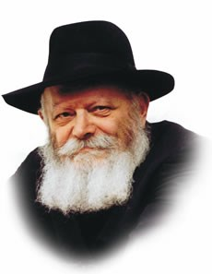

This week we read two Torah portions, Matot and Masei. Masei, meaning journeys, delineates the various travels of the Jews in the desert.

When the Jews left Egypt, they were beginning one long journey. Their departure from Egypt and their travels in the desert were all so that eventually the Jews would enter the Land of Israel. It would seem, then, that each of the forty-two stops they made along the way between Egypt and Israel was not really that significant. The stops presented an opportunity for the Jewish camp, comprised of millions of people, to take care of their various needs.

Yet, each and every stop the Jews made in the desert is mentioned separately, and each one is considered its own journey. Didn't the Jews reach the desert -- and freedom -- immediately upon leaving the borders of Egypt?

In every generation, in each individual's life, there must be an Exodus from Egypt, a departure from one's own boundaries and limitations. However, simply "leaving" Egypt is not enough. We must know that even after working on ourselves and spiritually leaving Egypt, we are not finished. No matter what spiritual level we have attained, we can still go further, we are still bound by our "Egypt." We must begin a new "journey," getting stronger and stronger as we go along.

There is a two-fold lesson from these "journeys."

Even when one has already attained a high level, one must never be content with what one has already achieved. Our whole purpose is to move in an upward spiritual direction -- never to stagnate and remain in the same place. Each day that is granted to us by G-d should be utilized for fulfilling this mission. However, we must be cognizant that in relation to what is above us and what we can still achieve, we are still in Egypt.

On the other hand, one must never despair of all there is left to achieve and of one's lowly, spiritual state. One must remember that it is possible, through work, to leave "Egypt" immediately, with only one journey. We must never think that our toil is in vain; with one move we can elevate ourselves and reach the "good and wide land" -- the Land of Israel.

*Reprinted from the 5756/1996 Parshat Matos-Masei edition of L’Chaim Weekly. Adapted from Likutei Sichot of the Lubavitcher Rebbe, Vol. 2*

**The Legacy of**

**Donato Manduzio**

**By Rabbi Yehoshua Alt**

The Chassam Sofer among others [ See the Agudas Azov in his Haggada, p. 14b, s.v. Asher] tells us that when the non-Jews were offered the Torah, they refused to accept it. [Devarim 33:2, Rashi.] Nevertheless, although the nation as a whole refused to accept it, there were individuals who did want to accept it. The souls of these people are the souls of those in each generation who come to convert to Judaism.

The following are some fascinating accounts of converts in recent history. Donato Manduzio (1885-1948), from San Nicandro, Italy, was a farmer’s son who had never set foot in a school. During World War One, he was drafted into the army and wounded, and then hospitalized in a military hospital. In the bed adjacent to him lay a wounded man who taught him to read and write, and so he began to read books.

[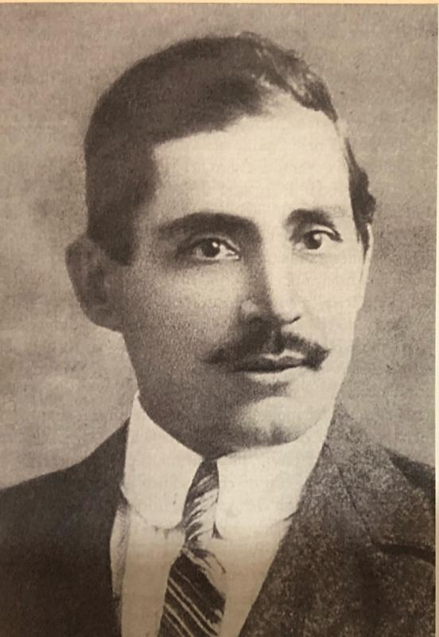](https://images1.ynet.co.il/PicServer5/2018/04/23/8486605/IMG_0297.jpg)

**Donato Manduzio**

When he returned to San Nicandro he read a great deal of Italian literature. On a night in 1930, he had a “divine revelation” which spurred him to study the Old Testament. He came to the conclusion that Judaism is the true religion. He then began observing Shabbos and gradually other mitzvos.

More and more of his neighbors joined him in his spiritual quest, and he established the San Nicandro Jewish community, which at its height numbered 80 people. When he learned that there were thousands of Jews living in Rome, Milan, and Florence, he was stunned because he was convinced that the people of Israel he had read about in the Old Testament were extinct and no longer existed.

He then sent them letters. After a lengthy exchange of correspondence, where among his requests was to have recordings (through a gramophone) of all the songs sung in the Temple because he wanted to sing them that way, the Jewish community of Rome concluded that the San Nicandro community was serious and worthy of being converted.

The Chief Rabbi of Rome Rabbi Dr David Prato dispatched a messenger to visit these people and on that visit, the village’s first shul was dedicated and the community received Tallasim (prayer shawls), a menorah and several other religious articles.

Despite the rise of fascism and hatred towards Jews at that time, they adopted a Jewish lifestyle with courage and determination and did not give up even after Mussolini (fascist dictator of Italy from 1925 to 1945) decreed the racial laws against the Jews in 1938. The racial laws against the Jews of Italy were not applied against Manduzio and his followers, due to their Italian Catholic origin, despite their insistence on telling Italian fascist policemen and later the German Nazi soldiers who entered the village that they were Jews.

**The Jewish Brigade Passed Through the Village**

Luckily, no one believed them. In October 1943, after Allied forces had invaded Italy, members of the Jewish Brigade passed through the village, with Stars of David emblazoned on their jeeps. The Jewish soldiers were astonished to meet Jewish farmers in the remote village. For Donato and his followers, it was their first encounter with real, live Jews. Members of the Jewish Brigade urged the people of San Nicandro to immigrate to Israel, telling them a Jew’s place was in the Land of Israel.

In 1946, the rabbinate in Rome converted the community. In the years 1947-1949, 74 members of the San Nicandro community immigrated to Israel on ships. They settled in three communities: Ashkelon, Bat Yam and Tzefas. A few months prior to the establishment of the State of Israel, Manduzio passed away and was buried in the Jewish section of the small cemetery in San Nicandro. On his grave is a Star of David and the inscription: “Here is buried he who lived under the delusion of worshipping foreign gods until 1930, but on August 11 of that year, by Divine inspiration, called himself Levi, proclaimed the unity of G-d and the observance of the Shabbos.”

In Brazil today there are many converts to Judaism. From 2015 until 2018, at least 400 people with Sefardic ancestry have undergone Orthodox conversions to Judaism in northern Brazil – the area where their ancestors first arrived from Europe. And let us not forget the many converts in Bello, Columbia. How did this come about? A minister of an Evangelical church visited Israel in 1998 and in 2003 and felt a pull to Judaism. He returned to the city of Bello and told his people that he plans to convert to Judaism! Not only did he convert but 150 families joined him! (Rabbi Yehoshua Alt - [yalt3285@gmail.com](mailto:yalt3285@gmail.com))

*Reprinted from the Parshas Mattos-Masei 5781 email of Reb Yedidye Hirtefeld’s whY I Matter parsha sheet of the Young Israel of Midwood in Brooklyn.*